Name : Ma Hnin Yee Aye

Case study 3

Task(1) and Task(2)

1. Admin Entity

* admin_id
* admin_name
* admin_email
* admin_password

1. Customer Entity

* cus_id
* cus_name
* cus_address
* cus_mobile

1. Staff Entity

* staff_id
* staff_name
* staff_password
* staff_email
* staff_admin_id

1. Shoe Entity

* shoe_id
* shoe_color
* shoe_type
* shoe_size
* shoe_cus_id
* shoe_staff_id

1. Payment Entity

* payment_id
* payment_amount
* payment_date
* payment_cus_id
* payment_admin_id

Task 3 :ER Diagram for case 3

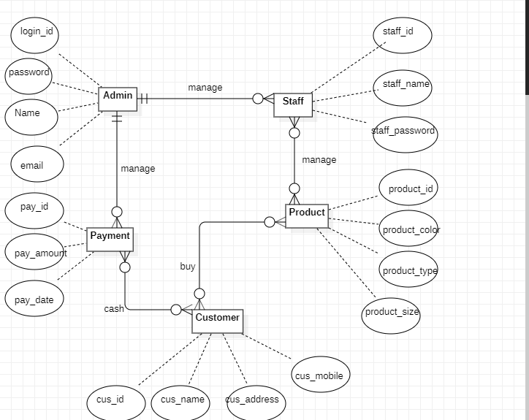

Case 3: Class Diagram for case 3

